**Q1)**Create the following classes:

class Fruit { String name; int calories; int price; String color; }

**Display the following:**

**1. Display the fruit names of low calories fruits i.e. calories < 100 sorted in descending order of calories.**

**2. Display color wise list of fruit names.**

**3. Display only RED color fruits sorted as per their price in ascending order.**

**Code Specifications:**

**c**lass Fruit {  
    private String name;  
    private int calories;  
    private int price;  
    private String color;  
}  
  
public class Assignment5Q1 {

    public static List<String>reverseSort(ArrayList<Fruit> fruits) {}  
    public static ArrayList<Fruits> sort(ArrayList<Fruits> Fruits) {}

    public static ArrayList<Fruit>filterRedSortPrice(ArrayList<Fruit>

    public static void main(String[] args) {}

}

**Code: package** StreamsAssignment;

**import** java.util.*;

**import** java.util.stream.Collectors;

**import** java.util.stream.Stream;

**class** Fruits {

String name;

**int** calories;

**int** price;

String color;

**public** String getName() {

**return** name;

}

**public** **void** setName(String name) {

**this**.name = name;

}

**public** **int** getCalories() {

**return** calories;

}

**public** **void** setCalories(**int** calories) {

**this**.calories= calories;

}

**public** **int** getPrice() {

**return** price;

}

**public** **void** setPrice(**int** price) {

**this**.price= price;

}

**public** String getColor() {

**return** color;

}

**public** **void** setColor(String color) {

**this**.color= color;

}

@Override

**public** **boolean** equals(Object o) {

**if** (**this** == o) **return** **true**;

**if** (!(o **instanceof** Fruits)) **return** **false**;

Fruits fruits= (Fruits) o;

**return** calories == fruits.calories&&price == fruits.price&&color.equals(fruits.color);

}

@Override

**public** **int** hashCode() {

**return** Objects.*hash*(calories, price, color);

}

**public** **static** Comparator<Fruits>*color1* = **new** Comparator<Fruits>() {

@Override

**public** **int** compare(Fruits o1, Fruits o2) {

**return** o1.getColor().compareTo(o2.getColor());

}

};

**public** **static** Comparator<Fruits>*calories1* = **new** Comparator<Fruits>() {

**public** **int** compare(Fruits f1,Fruits f2){

**return** f2.getCalories()-f1.getCalories();

}

};

**public** **static** Comparator<Fruits>*price1* = **new** Comparator<Fruits>() {

@Override

**public** **int** compare(Fruits o1, Fruits o2) {

**return** o1.getPrice()-o2.getPrice();

}

};

}

**public** **class** Assignment7Q1 {

**public** **static** List<String>reverseSort(ArrayList<Fruits>fruits) {

List<String>list = **new** ArrayList<>();

ArrayList<Fruits>fruits2 = **new** ArrayList<>();

fruits2 = (ArrayList<Fruits>) fruits.stream().filter((fruits1 -> {**return** fruits1.getCalories()<100;})).collect(Collectors.*toList*());

Collections.*sort*(fruits2,Fruits.*calories1*);

**for**(Fruits f: fruits2){

String string= f.getName();

list.add(string);

}

**return** list;

}

**public** **static** ArrayList<Fruits>sort(ArrayList<Fruits>fruits) {

Collections.*sort*(fruits,Fruits.*color1*);

**return** fruits;

}

**public** **static** ArrayList<Fruits>filterRedSortPrice(ArrayList<Fruits>fruits){

fruits = (ArrayList<Fruits>) fruits.stream().filter((fruits1 -> {**return** fruits1.getColor().toUpperCase().equals("RED");})).collect(Collectors.*toList*());

Collections.*sort*(fruits,Fruits.*price1*);

**return** fruits;

}

**public** **static** **void** main(String[] args) {

ArrayList<Fruits>arrayList= **new** ArrayList<>();

**int** choice;

Scanner sc= **new** Scanner(System.***in***);

**do** {

System.***out***.println("\n1. ENTER THE FRUITS");

System.***out***.println("2. DISPLAY THE FRUITS");

System.***out***.println("3. DISPLAY THE FRUIT NAMES OF LOW CALORIES FRUITS");

System.***out***.println("4. DISPLAY COLOR WISE LIST OF FRUIT NAMES");

System.***out***.println("5. DISPLAY ONLY RED COLOR FRUITS SORTED AS PER THEIR PRICE IN ASCENDING ORDER");

System.***out***.println("6. EXIT");

System.***out***.println("ENTER YOUR CHOICE: ");

choice = sc.nextInt();

**switch** (choice){

**case** 1:

Fruits fruits= **new** Fruits();

System.***out***.print("Enter the name of fruit: ");

String name = sc.next();

fruits.setName(name);

System.***out***.print("Enter the calories in fruit: ");

**int** calories = sc.nextInt();

fruits.setCalories(calories);

System.***out***.print("Enter the price of the fruit: ");

**int** price = sc.nextInt();

fruits.setPrice(price);

System.***out***.print("Enter the color of the fruit: ");

String color= sc.next();

fruits.setColor(color);

arrayList.add(fruits);

**break**;

**case** 2:

System.***out***.println("Fruits in the List are: ");

**for**(Fruits i: arrayList){

System.***out***.println("Name: "+i.getName()+", Calories: "+i.getCalories()+", Price: "+i.getPrice()+", Color: "+i.getColor());

}

**break**;

**case** 3: List<String>list = **new** ArrayList<>();

list = *reverseSort*(arrayList);

**for** (String str: list){

System.***out***.println("Fruit Name: "+str);

}

**break**;

**case** 4: ArrayList<Fruits>arrayList1 = **new** ArrayList<>();

arrayList1 = *sort*(arrayList);

**for**(Fruits fruits1: arrayList1){

System.***out***.println("Fruit Name: "+fruits1.getName()+", Fruit Color: "+fruits1.getColor());

}

**break**;

**case** 5: ArrayList<Fruits>arrayList2 = **new** ArrayList<>();

arrayList2 = *filterRedSortPrice*(arrayList);

**for** (Fruits fruits1: arrayList2){

System.***out***.println("Fruit Name: "+fruits1.getName()+", Fruit Price: "+fruits1.getPrice());

}

**break**;

**case** 6: System.*exit*(0);

**default**:

System.***out***.println("PLEASE ENTER THE RIGHT CHOICE!!");

}

}**while** (choice!=6);

}

}

**Output:** 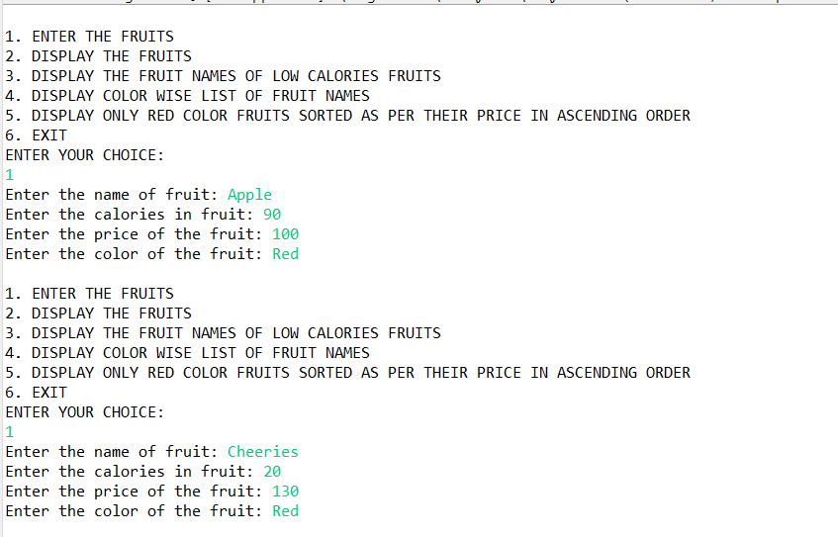 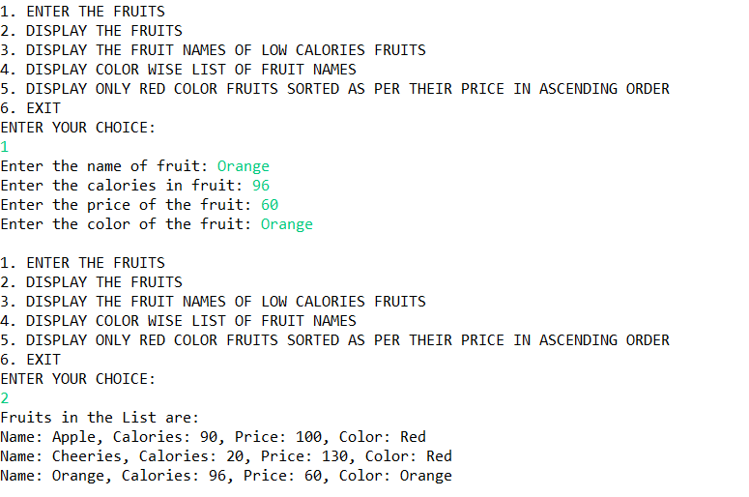 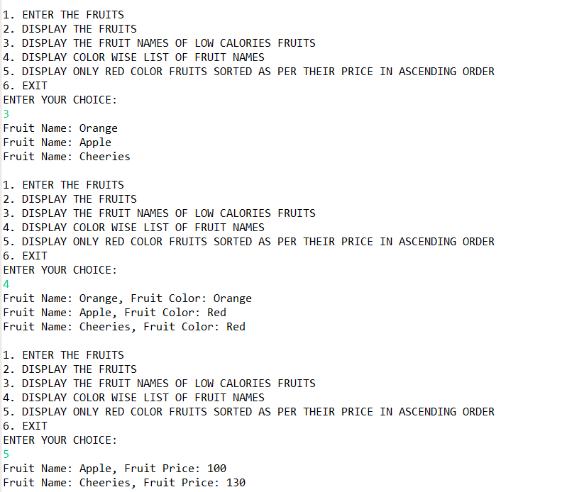 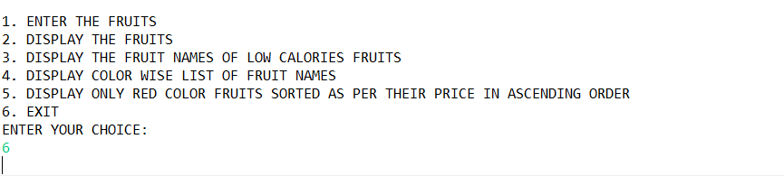

**Q2)**Setup:

Create the following classes:

class News { int newsId; String postedByUser; String commentByUser; String comment; }

**Find Out:**

**1. Find out the newsId which has received maximum comments.**

**2. Find out how many times the word 'budget' arrived in user comments all news.**

**3. Find out which user has posted maximum comments.**

**4. Display commentByUser wise number of comments.**

**Code Specifications:**

class News {  
    private int newsId;  
    private String postedByUser;  
    private String commentByUser;  
    private String comment;  
}  
  
public class Assignment5Q2 {  
    public static int maxComments(List<News> news) {}

    public static int budgetCount (List < News > news) {}  
    public static String maxCommentsByUser (List < News > news) {}

    public static Map<String, Integer>sortMaxCommentsByUser (List < News > news) {}

    public static void main(String[] args) {}  
}

**Code:**

**package** StreamsAssignment;

**import** java.util.*;

**import** java.util.stream.Collectors;

**class** News {

**int** newsId;

String postedByUser;

String commentByUser;

String comment;

**public** News(**int** newsId, String postedByUser, String commentByUser, String comment) {

**this**.newsId = newsId;

**this**.postedByUser = postedByUser;

**this**.commentByUser = commentByUser;

**this**.comment = comment;

}

**public** News() {

}

**public** **int** getNewsId() {

**return** newsId;

}

**public** **void** setNewsId(**int** newsId) {

**this**.newsId = newsId;

}

**public** String getPostedByUser() {

**return** postedByUser;

}

**public** **void** setPostedByUser(String postedByUser) {

**this**.postedByUser= postedByUser;

}

**public** String getCommentByUser() {

**return** commentByUser;

}

**public** **void** setCommentByUser(String commentByUser) {

**this**.commentByUser= commentByUser;

}

**public** String getComment() {

**return** comment;

}

**public** **void** setComment(String comment) {

**this**.comment= comment;

}

@Override

**public** **boolean** equals(Object o) {

**if** (**this** == o) **return** **true**;

**if** (!(o **instanceof** News)) **return** **false**;

News news= (News) o;

**return** newsId== news.newsId&&commentByUser.equals(news.commentByUser) &&comment.equals(news.comment);

}

@Override

**public** **int** hashCode() {

**return** Objects.*hash*(newsId, commentByUser, comment);

}

}

**public** **class** Assignment7Q2 {

**public** **static** **int** maxComments(List<News>news) {

Map<Integer,Integer>map = **new** HashMap<>();

**for** (News news1: news){

**int** id = news1.getNewsId();

**if**(map.containsKey(id)){

map.put(id,map.get(id)+1);

} **else** {

map.put(id,1);

}

}

List<Map.Entry<Integer, Integer>>list = **new** ArrayList<>(map.entrySet());

list.sort(Map.Entry.*comparingByValue*());

**return** list.get(list.size()-1).getKey();

}

**public** **static** **int** budgetCount(List <News >news) {

**int** count = 0;

List<String>list = **new** ArrayList<>();

**for**(News i: news){

String comment = i.getComment();

list.add(Arrays.*toString*(comment.split("budget")));

}

**return** list.size();

}

**public** **static** String maxCommentsByUser(List <News >news) {

Map<String,Integer>map = **new** HashMap<>();

**for**(News news1: news){

String username = news1.getCommentByUser();

**if**(map.containsKey(username)){

map.put(username,map.get(username)+1);

} **else** {

map.put(username,1);

}

}

List<Map.Entry<String, Integer>>list = **new** ArrayList<>(map.entrySet());

list.sort(Map.Entry.*comparingByValue*());

**return** list.get(list.size()-1).getKey();

}

**public** **static** Map<String, Integer>sortMaxCommentsByUser(List <News >news) {

Map<String,Integer>map = **new** HashMap<>();

**for**(News news1: news){

String username = news1.getCommentByUser();

**if**(map.containsKey(username)){

map.put(username,map.get(username)+1);

} **else** {

map.put(username,1);

}

}

HashMap<String, Integer>temp

= map.entrySet()

.stream()

.sorted((i1, i2)

->i2.getValue().compareTo(

i1.getValue()))

.collect(Collectors.*toMap*(

Map.Entry::getKey,

Map.Entry::getValue,

(e1, e2) ->e1, LinkedHashMap::**new**));

**return** temp;

}

**public** **static** **void** main(String[] args) {

List<News>list = **new** ArrayList<>();

**int** choice;

Scanner sc= **new** Scanner(System.***in***);

News news1 = **new** News(1,

"Premal Miglani",

"Mihir Gaikwad",

"I want to know about the budget");

News news2 = **new** News(1,

"Premal Miglani",

"Prateek Sengar",

"budget is my fundamental right");

News news3 = **new** News(2,

"Prateek Sengar",

"Prathmesh Asole",

"budget 2022");

list.add(news1);

list.add(news2);

list.add(news3);

**do**{

System.***out***.println("1. ENTER THE NEWS DETAILS");

System.***out***.println("2. DISPLAY THE NEWS DETAILS");

System.***out***.println("3. FIND OUT THE newsId WHICH HAS RECEIVED MAXIMUM COMMENTS.");

System.***out***.println("4. FIND OUT HOW MANY TIMES THE WORD 'BUDGET' ARRIVED IN USER COMMENTS ALL NEWS.");

System.***out***.println("5. FIND OUT WHICH USER HAS POSTED MAXIMUM COMMENTS.");

System.***out***.println("6. DISPLAY COMMENT BY USER WISE NUMBER OF COMMENTS.");

System.***out***.println("7. EXIT");

System.***out***.println("ENTER YOUR CHOICE:");

choice = sc.nextInt();

**switch** (choice){

**case** 1:

News news= **new** News();

**try** {

System.***out***.print("Enter the newsID: ");

**int** newId= sc.nextInt();

news.setNewsId(newId);

sc.nextLine();

System.***out***.print("Enter the name who posted the news: ");

String name = sc.nextLine();

news.setPostedByUser(name);

System.***out***.print("Enter the comment: ");

String comment = sc.nextLine();

news.setComment(comment);

System.***out***.print("Enter the name who posted the comment: ");

String username = sc.nextLine();

news.setCommentByUser(username);

list.add(news);

}**catch** (Exception e){

System.***out***.println(e);

System.***out***.println("Enter the correct input please!!");

}

**break**;

**case** 2: **for**(News new1: list){

System.***out***.println("News ID: "+new1.getNewsId());

System.***out***.println("News Posted By: "+new1.getPostedByUser());

System.***out***.println("Comment by User: "+new1.getCommentByUser());

System.***out***.println("Comment Posted: "+new1.getComment());

System.***out***.println();

}

**break**;

**case** 3: **int** id = *maxComments*(list);

System.***out***.println("NEWS ID WHICH HAS RECEIVED MAXIMUM COMMENTS: "+id);

System.***out***.println();

**break**;

**case** 4: **int** countBudget= *budgetCount*(list);

System.***out***.println("HOW MANY TIMES THE WORD 'BUDGET' ARRIVED IN USER COMMENTS ALL NEWS: "+countBudget);

System.***out***.println();

**break**;

**case** 5: String name = *maxCommentsByUser*(list);

System.***out***.println("USER HAS POSTED MAXIMUM COMMENTS: "+name);

System.***out***.println();

**break**;

**case** 6: Map<String,Integer>maxCommentByUser= *sortMaxCommentsByUser*(list);

**for** (Map.Entry<String,Integer>mp: maxCommentByUser.entrySet()){

System.***out***.println("Name of the User: "+mp.getKey());

System.***out***.println("Numbers of Comments: "+mp.getValue());

System.***out***.println();

}

System.***out***.println();

**break**;

}

}**while** (choice!=7);

}

}

**Output:**

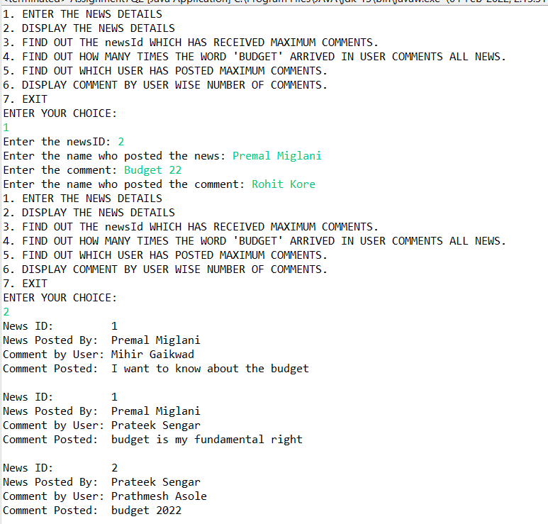 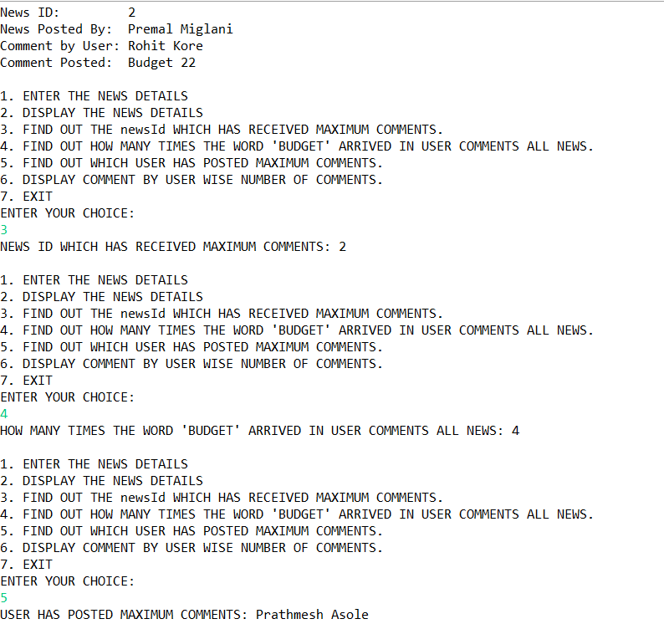 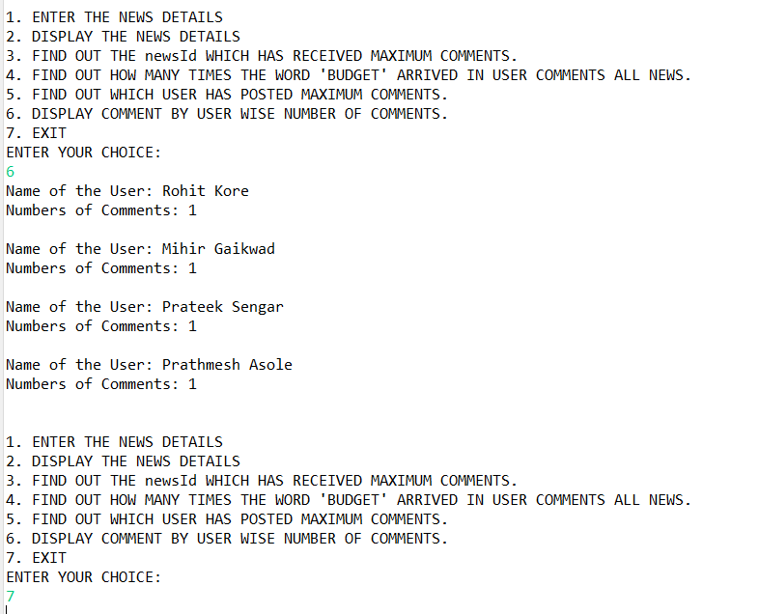

**Q3)**Setup:

Create the following classes:

class Trader { String name; String city; }

**Find Out:**

**1. What are all the unique cities where the traders work?**

**2. Find all traders from Pune and sort them by name.**

**3. Return a string of all traders’ names sorted alphabetically.**

**4. Are any traders based in Indore?**

**Code Specifications:**

class Trader {  
    private String name;  
    private String city;  
}  
  
public class Assignment5Q9 {  
    public static List<String>printUniqueCities (List <Trader> traders) {  }

    public static List<String>tradersFromPuneSortByName(List<Trader> traders) {}  
    public static String allTrader3Names(List<Trader> traders) {}  
    public static ArrayList<Trader>areAnyTradersFromIndore(ArrayList<Trader> traders) {}

    public static void main(String[] args) {}  
}

**Code:**

**package** StreamsAssignment;

**import** java.util.*;

**class** Trader {

String name;

String city;

**public** Trader(String name, String city) {

**this**.name = name;

**this**.city = city;

}

**public** Trader(){

}

**public** String getName() {

**return** name;

}

**public** **void** setName(String name) {

**this**.name = name;

}

**public** String getCity() {

**return** city;

}

**public** **void** setCity(String city) {

**this**.city = city;

}

@Override

**public** **boolean** equals(Object o) {

**if** (**this** == o) **return** **true**;

**if** (!(o **instanceof** Trader)) **return** **false**;

Trader trader= (Trader) o;

**return** name.equals(trader.name) &&city.equals(trader.city);

}

@Override

**public** **int** hashCode() {

**return** Objects.*hash*(name, city);

}

**public** **static** Comparator<Trader>*comparator* = **new** Comparator<Trader>() {

@Override

**public** **int** compare(Trader o1, Trader o2) {

**return** o1.getName().compareTo(o2.getName());

}

};

}

**public** **class** Assignment7Q3 {

**public** **static** List<String>printUniqueCities(List <Trader>traders) {

Map<String,String>map = **new** HashMap<>();

List<String>cities = **new** ArrayList<>();

**for** (Trader trader: traders){

map.putIfAbsent(trader.getCity(),trader.getName());

}

**for** (Map.Entry<String,String>mp: map.entrySet()){

cities.add(mp.getKey());

}

**return** cities;

}

**public** **static** List<String>tradersFromPuneSortByName(List<Trader>traders) {

List<String>tradersFromPune= **new** ArrayList<>();

**for** (Trader trader: traders){

**if**(trader.getCity().toUpperCase().equals("PUNE")){

tradersFromPune.add(trader.getName());

}

}

Collections.*sort*(tradersFromPune);

**return** tradersFromPune;

}

**public** **static** List<Trader>allTrader3Names(List<Trader>traders) {

traders.sort(Trader.*comparator*);

**return** traders;

}

**public** **static** ArrayList<Trader>areAnyTradersFromIndore(ArrayList<Trader>traders) {

ArrayList<Trader>traderList= **new** ArrayList<>();

**for**(Trader trader: traders){

**if**(trader.getCity().toUpperCase().equals("INDORE")){

traderList.add(trader);

}

}

**return** traderList;

}

**public** **static** **void** main(String[] args) {

Scanner sc= **new** Scanner(System.***in***);

ArrayList<Trader>arrayList= **new** ArrayList<>();

Trader trader1 = **new** Trader("Premal Miglani","Nagpur");

Trader trader2 = **new** Trader("Ankit Dixit","Mumbai");

Trader trader3 = **new** Trader("Rajan Rathour","Nasik");

Trader trader4 = **new** Trader("Prateek Sengar","Pune");

Trader trader5 = **new** Trader("Rohit Kore","Pune");

arrayList.add(trader1);

arrayList.add(trader2);

arrayList.add(trader3);

arrayList.add(trader4);

arrayList.add(trader5);

**int** choice;

**do**{

System.***out***.println("\n1. ENTER THE TRADERS DETAILS");

System.***out***.println("2. DISPLAY THE TRADERS DETAILS");

System.***out***.println("3. DISPLAY ALL UNIQUE CITIES WHERE TRADERS WORK");

System.***out***.println("4. DISPLAY ALL TRADERS FROM PUNE SORTED BY NAME");

System.***out***.println("5. DISPLAY ALL TRADERS NAMES SORTED ALPHABETICALLY");

System.***out***.println("6. DISPLAY ALL TRADERS FROM INDORE");

System.***out***.println("7. EXIT");

System.***out***.println("ENTER YOUR CHOICE");

choice = sc.nextInt();

**switch** (choice){

**case** 1:

Trader trader= **new** Trader();

sc.nextLine();

System.***out***.println("Enter the Trader Name: ");

String name = sc.nextLine();

trader.setName(name);

System.***out***.println("Enter the City Name: ");

String city = sc.nextLine();

trader.setCity(city);

arrayList.add(trader);

**break**;

**case** 2:

System.***out***.println("List of traders: ");

**for** (Trader trade: arrayList){

System.***out***.println("Trader Name: "+trade.getName());

System.***out***.println("Trader City: "+trade.getCity());

}

System.***out***.println();

**break**;

**case** 3:

List<String>list = **new** ArrayList<>();

list = *printUniqueCities*(arrayList);

System.***out***.println("All uniques cities where traders work: ");

**for** (String str: list){

System.***out***.println(str);

}

System.***out***.println();

**break**;

**case** 4:

List<String>list1 = **new** ArrayList<>();

list1 = *tradersFromPuneSortByName*(arrayList);

System.***out***.println("All traders from Pune: ");

**for** (String str: list1){

System.***out***.println(str);

}

System.***out***.println();

**break**;

**case** 5: List<Trader>arraylist2 = **new** ArrayList<>();

arraylist2 = *allTrader3Names*(arrayList);

System.***out***.println("All Traders Name:");

**for**(Trader trader7: arraylist2){

System.***out***.println("Name: "+trader7.getName());

System.***out***.println("City: "+trader7.getCity());

System.***out***.println();

}

System.***out***.println();

**break**;

**case** 6: List<Trader>traderList= **new** ArrayList<>();

traderList= *areAnyTradersFromIndore*(arrayList);

System.***out***.println("All traders from Indore: ");

**for**(Trader trader7: traderList){

System.***out***.println("Name: "+trader7.getName());

}

System.***out***.println();

**break**;

**case** 7: System.*exit*(0);

**default**:

System.***out***.println("PLEASE ENTER THE RIGHT CHOICE!");

}

}**while** (choice!=7);

}

}

**Output:**

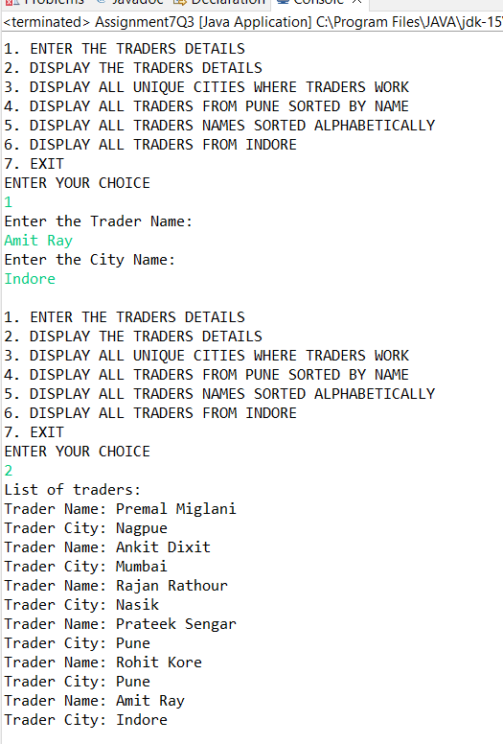 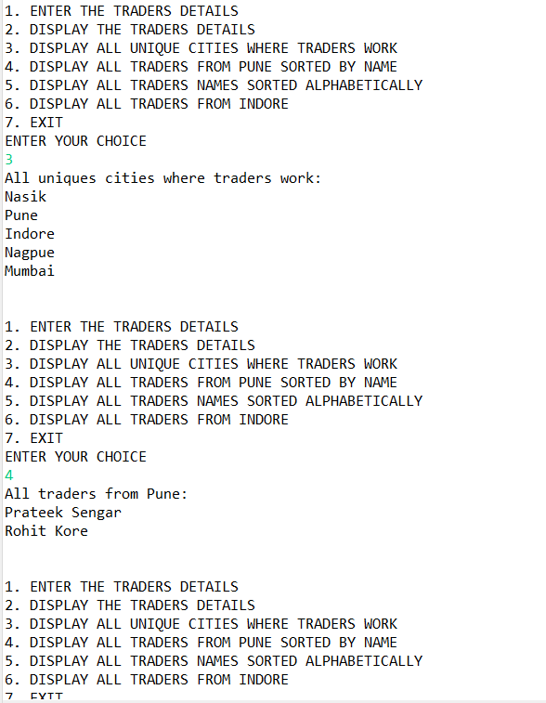 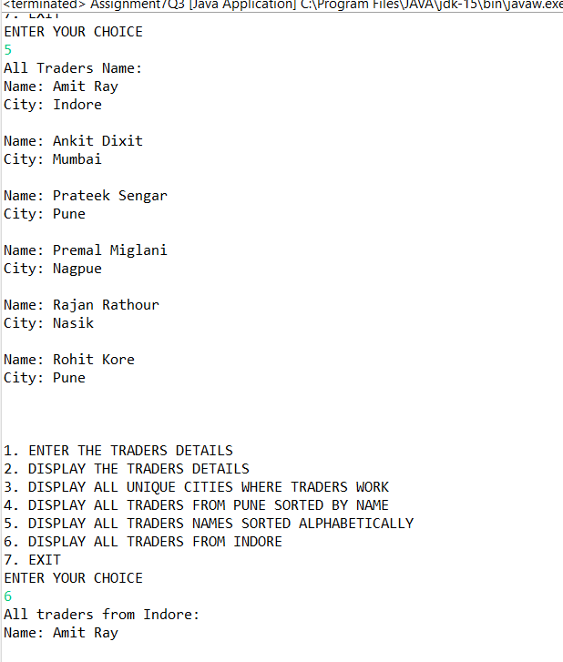 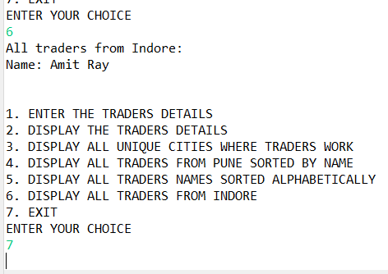

**Q4)**Setup:

Create the following classes:

class Trader { String name; String city; }

class Transaction { Tradertrader; int year; int value; }

**1. Find all transactions in the year 2011 and sort them by value (small to high).**

**2. Print all transactions’ values from the traders living in Delhi.**

**3. What’s the highest value of all the transactions?**

**4. Find the transaction with the smallest value.**

**Code Specifications:**

class Trader {  
    private String name;  
    private String city;  
}  
  
class Transaction {  
    private Trader trader;  
    private int year;  
    private int value;  
}  
public class Assignment5Q4 {  
    public static List<Transaction>sortTransactions(List <Transaction> transactions) {}

    public static List<Integer>transactionsValuesDelhi(List<Transaction> transactions) {}  
    public static int highestTransaction(List<Transaction> transactions){}

    public static int smallestTransaction(List<Transaction> transactions){}

    public static void main(String[] args) {}  
}

**Code:**

**package** StreamsAssignment;

**import** java.util.*;

**import** java.util.stream.Collectors;

**class** Trader1 {

String name;

String city;

**public** Trader1(String name, String city) {

**this**.name = name;

**this**.city = city;

}

**public** Trader1(){

}

**public** String getName() {

**return** name;

}

**public** **void** setName(String name) {

**this**.name = name;

}

**public** String getCity() {

**return** city;

}

**public** **void** setCity(String city) {

**this**.city = city;

}

@Override

**public** **boolean** equals(Object o) {

**if** (**this** == o) **return** **true**;

**if** (!(o **instanceof** Trader1)) **return** **false**;

Trader1 trader1 = (Trader1) o;

**return** name.equals(trader1.name) &&city.equals(trader1.city);

}

@Override

**public** **int** hashCode() {

**return** Objects.*hash*(name, city);

}

}

**class** Transaction {

Trader1 trader1;

**int** year;

**int** value;

**public** Transaction(){}

**public** Transaction(Trader1 trader1, **int** year, **int** value) {

**this**.trader1 = trader1;

**this**.year = year;

**this**.value = value;

}

**public** Trader1 getTrader1() {

**return** trader1;

}

**public** **void** setTrader1(Trader1 trader1) {

**this**.trader1 = trader1;

}

**public** **int** getYear() {

**return** year;

}

**public** **void** setYear(**int** year) {

**this**.year = year;

}

**public** **int** getValue() {

**return** value;

}

**public** **void** setValue(**int** value) {

**this**.value = value;

}

@Override

**public** **boolean** equals(Object o) {

**if** (**this** == o) **return** **true**;

**if** (!(o **instanceof** Transaction)) **return** **false**;

Transaction that = (Transaction) o;

**return** year == that.year &&value == that.value &&trader1.equals(that.trader1);

}

@Override

**public** **int** hashCode() {

**return** Objects.*hash*(trader1, year, value);

}

**public** **static** Comparator<Transaction>*MaximumValue* = **new** Comparator<Transaction>() {

@Override

**public** **int** compare(Transaction o1, Transaction o2) {

**return** o1.getValue()-o2.getValue();

}

};

}

**public** **class** Assignment7Q4 {

**public** **static** List<Transaction>sortTransactions(List <Transaction>transactions) {

transactions = transactions.stream().filter((t1)->t1.getYear()==2011).collect(Collectors.*toList*());

transactions.sort(Transaction.*MaximumValue*);

**return** transactions;

}

**public** **static** List<Integer>transactionsValuesDelhi(List<Transaction>transactions) {

List<Integer>transactionValue = **new** ArrayList<>();

transactions = transactions.stream().filter((t1)->t1.getTrader1().getCity().toUpperCase().equals("DELHI")).collect(Collectors.*toList*());

**for**(Transaction t1: transactions){

transactionValue.add(t1.getValue());

}

**return** transactionValue;

}

**public** **static** **int** highestTransaction(List<Transaction>transactions){

**int** MaxTransaction;

MaxTransaction = transactions.stream().mapToInt(Transaction::getValue).max().orElseThrow(NoSuchElementException::**new**);

**return** MaxTransaction;

}

**public** **static** **int** smallestTransaction(List<Transaction>transactions){

**return** transactions.stream().mapToInt(Transaction::getValue).min().orElseThrow(NoSuchElementException::**new**);

}

**public** **static** **void** main(String[] args) {

List<Transaction>arraylist = **new** ArrayList<>();

Scanner sc= **new** Scanner(System.***in***);

**int** choice;

**do**{

System.***out***.println("1. ENTER THE DETAILS OF TRADERS & THEIR TRANSACTIONS");

System.***out***.println("2. DISPLAY THE DETAILS OF TRADERS & THEIR TRANSACTION");

System.***out***.println("3. DISPLAY ALL TRANSACTIONS IN THE YEAR 2011 IN SORTED ORDER");

System.***out***.println("4. DISPLAY ALL TRANSACTIONS FROM TRADERS WHO LIVES IN DELHI");

System.***out***.println("5. DISPLAY THE HIGHEST VALUE OF ALL THE TRANSACTIONS");

System.***out***.println("6. DISPLAY THE SMALLEST VALUE OF ALL THE TRANSACTIONS");

System.***out***.println("7. EXIT");

System.***out***.println("ENTER YOUR CHOICE");

choice = sc.nextInt();

**switch** (choice){

**case** 1:

Transaction transaction = **new** Transaction();

Trader1 trader1= **new** Trader1();

sc.nextLine();

System.***out***.print("ENTER THE NAME OF THE TRADER: ");

String name = sc.nextLine();

trader1.setName(name);

System.***out***.print("ENTER THE CITY NAME OF THE TRADER: ");

String city = sc.nextLine();

trader1.setCity(city);

transaction.setTrader1(trader1);

System.***out***.print("ENTER THE YEAR OF TRANSACTION: ");

**int** year = sc.nextInt();

transaction.setYear(year);

System.***out***.print("ENTER THE AMOUNT OF TRANSACTION: ");

**int** amount = sc.nextInt();

transaction.setValue(amount);

arraylist.add(transaction);

**break**;

**case** 2:

System.***out***.println("List of all Traders and their Transactions");

**for** (Transaction t: arraylist){

System.***out***.println("Trader Name: "+t.getTrader1().getName());

System.***out***.println("Trader City: "+t.getTrader1().getCity());

System.***out***.println("Year: "+t.getYear());

System.***out***.println("Value: "+t.getValue());

System.***out***.println();

}

**break**;

**case** 3:

System.***out***.println("All the transactions in the year 2011 in sorted order: ");

List<Transaction>transactionList = **new** ArrayList<>();

transactionList = *sortTransactions*(arraylist);

**for** (Transaction t1: transactionList){

System.***out***.println("Trader Name: "+t1.getTrader1().getName());

System.***out***.println("Trader City: "+t1.getTrader1().getCity());

System.***out***.println("Value: "+t1.getValue());

System.***out***.println("Year: "+t1.getYear());

System.***out***.println();

}

**break**;

**case** 4:

System.***out***.println("All transactions from the traders lives in Delhi: ");

List<Integer>list = **new** ArrayList<>();

list = *transactionsValuesDelhi*(arraylist);

list.forEach(System.***out***::println);

**break**;

**case** 5: **int** Maxvalue = *highestTransaction*(arraylist);

System.***out***.println("Highest Transaction value: "+Maxvalue);

**break**;

**case** 6: **int** Minvalue = *smallestTransaction*(arraylist);

System.***out***.println("Lowest Transaction value: "+Minvalue);

**break**;

**case** 7: System.*exit*(0);

**default**:

System.***out***.println("PLEASE ENTER THE CORRECT CHOICE: ");

}

}**while** (choice!=7);

}

}

**Output:**

